# FUNDAMENTAL ANALYSIS: TESLA INC

## Company Description <DES>

Tesla Inc. operates as a multinational automotive and clean energy company. The Company designs and manufactures electric vehicles, battery energy storage from home to grid-scale, solar panels and solar roof tiles, and related products and services. Tesla owns its sales and service network and sells electric power train components to other automobile manufacturers.

### OVERVIEW

Founded in 2003, Tesla Motors designs, develops, manufactures, and markets high-performance, technologically advanced electric cars and solar energy generation and energy storage products. Tesla sells more than five fully electric cars, among others, the Model X and Y SUVs, as well as the Model S sedan and Model 3 sedan. The company has a growing global network of Tesla Superchargers, which are industrial grade, high-speed vehicle chargers, typically placed along well-traveled routes and in and around dense city centers to allow Tesla-owners quick and reliable charging.

### Company Background

Tesla Motors was incorporated in July 2003 in Delaware, US. The company was founded by a group of engineers who wanted to prove that people didn't need to compromise to drive electric. Today, Tesla builds not only all-electric vehicles but as well as infinitely scalable clean energy generation and storage products.

### Strategy

Generally, Tesla continues to expand production capacity at its existing facilities. It also intends to further increase cost-competitiveness in its significant markets by strategically adding local manufacturing, including at Gigafactory Berlin in Germany and Gigafactory Texas in Austin, Texas, which will begin production in 2022.

### Operations

Tesla operates in two reportable segments: Automotive and Energy generation and storage.

The automotive segment generates about 90% of sales. The segment includes sales and leasing of electric vehicles as well as sales of automotive regulatory credits. Additionally, the segment is also comprised of services and others. It accounts nearly 10% of sales and includes non-warranty after-sales vehicle services, sales of used vehicles, retail merchandise, sales by the acquired subsidiaries to third party customers and vehicle insurance revenue.

The company's energy generation and storage segment (just over 5% of revenue) makes and sells stationary energy storage products and solar energy systems to residential and small commercial customers, as well as large commercial and utility grade customers.

### Geographic Reach

Tesla, headquartered in Austin, Texas, operates a manufacturing facility in Fremont, California; and its Gigafactories near Sparks, Nevada; Buffalo, New York; Grunheide, Germany; and Shanghai, China. The US accounts for nearly 50% of sales. China accounts for roughly 30% of sales, while the rest of the market accounts for about 30%.

# Fundamental Analysis

Fundamental analysis (FA) is a method of [measuring a security's intrinsic value](https://www.investopedia.com/terms/v/valuation.asp) by examining related economic and financial factors. Fundamental analysis uses public data to evaluate the value of a stock or any other type of security. For stocks, fundamental analysis uses revenues, earnings, future growth, [return on equity](https://www.investopedia.com/terms/r/returnonequity.asp), profit margins, and other data to determine a company's underlying value and potential for future growth. The various fundamental factors can be grouped into two categories: quantitative and qualitative. quantitative fundamentals are hard numbers. They are the measurable characteristics of a business. That's why the biggest source of quantitative data is financial statements. Revenue, profit, assets, and more can be measured with great precision.

The qualitative fundamentals are less tangible. They might include the quality of a company's key executives, its brand-name recognition, [patents](https://www.investopedia.com/terms/p/patent.asp), and [proprietary technology](https://www.investopedia.com/terms/p/proprietarytechnology.asp).

## QUANTITATIVE FUNDAMENTAL ANALYSIS

### Profitability

Profitability is utmost significant parameter of fundamental analysis of a stock. We will be analyzing profitability using ratios like Return on Assets, Return on Equity, Gross Profit margin.

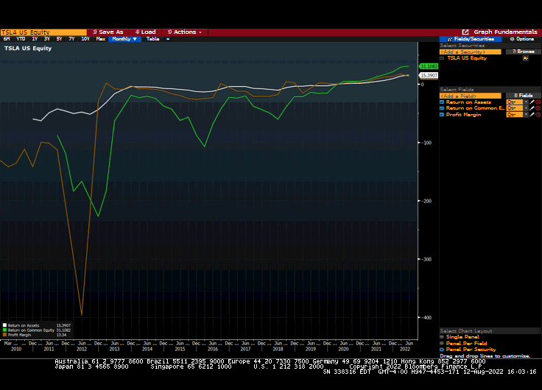

Using FA function, ratios of Tesla were recorded

|  |  |  |  |  |  |  |  |  |  |  |
| --- | --- | --- | --- | --- | --- | --- | --- | --- | --- | --- |
| **In Millions of USD except Per Share** | **FY 2015** | **FY 2016** | **FY 2017** | **FY 2018** | **FY 2019** | **FY 2020** | **FY 2021** | **Last 12M** | **FY 2022 Est** | **FY 2023 Est** |
| **12 Months Ending** | **12/31/2015** | **12/31/2016** | **12/31/2017** | **12/31/2018** | **12/31/2019** | **12/31/2020** | **12/31/2021** | **06/30/2022** | **12/31/2022** | **12/31/2023** |
| Return on Assets | -12.79 | -4.39 | -7.64 | -3.34 | -2.69 | 1.67 | 9.66 | 15.39 | 19.17 | 16.70 |
| Return on Common Equity | -87.01 | -22.91 | -43.59 | -21.31 | -14.94 | 4.78 | 21.04 | 31.11 | 33.64 | 33.25 |
| Profit Margin | -21.96 | -9.64 | -16.68 | -4.55 | -3.51 | 2.29 | 10.25 | 14.17 | 16.75 | 16.95 |
|  |  |  |  |  |  |  |  |  |  |  |

Second criteria Valuation

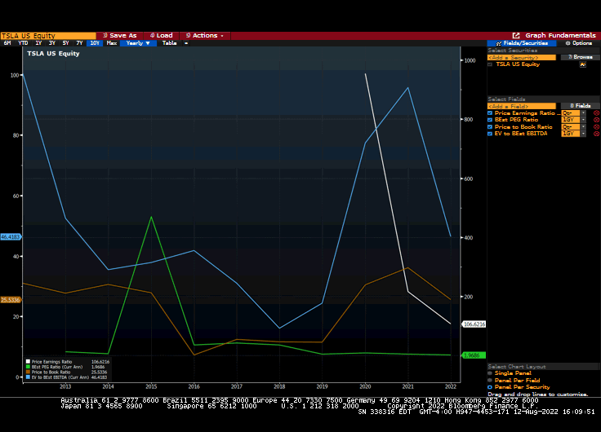

|  |  |  |  |  |  |  |  |  |  |  |  |
| --- | --- | --- | --- | --- | --- | --- | --- | --- | --- | --- | --- |
| **In Millions of USD except Per Share** | **FY 2015** | **FY 2016** | **FY 2017** | **FY 2018** | **FY 2019** | **FY 2020** | **FY 2021** | **Last 12M** | **FY 2022 Est** | **FY 2023 Est** |  |
| **12 Months Ending** | **12/31/2015** | **12/31/2016** | **12/31/2017** | **12/31/2018** | **12/31/2019** | **12/31/2020** | **12/31/2021** | **06/30/2022** | **12/31/2022** | **12/31/2023** |  |
| BEst PEG Ratio | 13.80 | — | — | — | — | 8.72 | 3.78 |  | 1.97 | 1.42 |  |
| Price Earnings Ratio (P/E) | — | — | — | — | — | 972.87 | 217.35 | 106.44 | 72.13 | 52.10 |  |
| Price to Book Ratio | 27.89 | 7.25 | 12.40 | 11.67 | 11.44 | 30.48 | 36.16 | 25.49 | 20.71 | 15.37 |  |
| Enterprise Value/EBITDA | 702.02 | 140.13 | 15,488.82 | 44.17 | 33.94 | 139.34 | 104.75 | 65.74 | 46.16 | 31.94 |  |

Growth